outline

Proposed Structure from Claude

1. Introduction (motivation/RQ — high weight)
- Hook: globalization and dietary convergence
- Clear research question stated explicitly, e.g. "To what extent do geographic and socioeconomic factors explain bilateral dietary similarity between countries?"
- Brief preview of data, method, findings

2. Related Literature (motivation)
- Finger & Kreinin (1979) — the index
- 1–2 papers on dietary patterns and geography/development
- Keep this short, 1 paragraph max

3. Data
- FAO food supply data, M49 country filter
- How shares are constructed
- Beverage exclusion
- Brief descriptive stats table of countries covered

4. Methodology (implementation)
- FK index formula, your three-category weighted extension
- Justify weights
- Aggregation to mean similarity for visualization
- Dyadic regression specification (Gravity Model)

5. Results (implementation)
- 5.1 Visualization: world map of similarity, prevalence of certain food categories, similarity of certain regions
- 5.2 Regression: which factors determine dyadic food similarity?
- 5.3 Case Study: Food similarity of ex-Soviet states over time (visually)

6. Conclusion
- Answer your RQ directly
- Limitations (weight assumption, aggregation sensitivity)

Descriptive Analysis
- Find some aggregation method, since we have dyadic similarity scores (so always between two countries)
- Options:
  - Display similarity to a certain country or the global average
  - Visualize similarity of certain regions (e.g. by continent)
- Maps we could do:
  - Heatmap visualizing food similarity
  - Heatmap visualizing food shares of certain categories, e.g. sea-food
  - Case Study: Similarity of ex-Soviet states over time (see below)
Regression analysis
Overview: Potential Determinants of Food Similarity between two Countries
Factor | Variable | Hypothesis | Data source
Geography | Geodesic distance / Shared Border TINA | Closer → more similar | CEPII GeoDist
Coastal access | Both/neither coastal TINA | Seafood diet convergence | Natural Earth
Elevation | Population weighted elevation | Similar elevation - similar foods
Climate | Köppen zone match ANA | Same zone → more similar | Raster: https://koppen.earth/
Culture / religion | Shared language, religion TINA | More similar diets | CEPII (language), UN M49 (religion)
Historical factors | colonial ties/common colonizer; shared statehood (more difficult) TINA | More similar | CEPII (colonial ties), https://www.arcgis.com/home/item.html?id=6b836b2859194fdfa156458f2d2842e9 (historical national borders), Correlates of War State System dataset (shared statehood)
Wealth | GDP per capita difference TINA | Large gap → less similar | World Bank
Trade | Bilateral trade volume TINA | More trade → more similar | CEPII BACI Dataset
Research question: How does geography influence the similarity of food consumption between countries?

Motivation and Literature Review: Research has long documented the fact that geography has a significant impact on people’s diets. For example, the Eurobarometer survey found that “proximity to the sea strongly influences higher consumption of fish and seafood” (European Commission, 2025). There are also well-documented similarities in food by region, such as countries like France, Italy, Spain and Greece tending to adhere to Mediterranean diets (Mertens et. al. 2018).

At the same time, there has been some literature documenting the relationship between geography and similarity in diet between countries. Zhu et. al. (2013) analyze geography and the regional similarity of food in China, while Mertens et. al. (2018) document similarity between selected European countries. We note that most of these studies have done so on a regional or country-specific level; our paper aims to do this analysis on a global scale.

In our paper, we investigate a few geographic variables that are likely significant determinants of diets: distance between countries, shared borders, (similarity in) climate zones, elevation, and distance to water bodies.

Data Description
We use the UN Food and Agriculture Organization’s Food Balance Sheets, which contains country-level data on the “pattern of a country’s food supply during a specified reference period”, including the amount consumed for each category of food (e.g. “Wheat and products”, “Groundnuts”, “Bovine meat”). To capture evolution over time, we use both 2010 and 2023 (earliest and latest available, respectively) data.

Data sources are as follows:

Variable | Data Source
Distance between countries | CEPII GeoDist  Calculated ourselves
Population-weighted elevation | Population grid data from WorldPop  Elevation raster from terra package in R
Climate zones | Koppen Geiger Climate Zones raster data
Distance to water bodies | Copernicus Water Bodies 2020-present raster
Gravity controls (common language, religious proximity index, common colonizer post 1945, colonial relationship post 1945, currently engaged in regional trade agreement) | CEPII Gravity
Bilateral trade volume | CEPII BACI
GDP Per Capita, PPP | World Bank
Population | World Bank

Methodology
Computation of Food Similarity Scores
We draw heavily from the methodology of the Country Food Similarity Index in calculating food similarity scores. While they do not specify the specific method by which they calculate similarity, we use the “Finger-Kreinin Index” commonly employed in trade literature to measure similarity in trade baskets (Finger and Kreinin, 1979). For each country, we first calculate the share of each category of food as a proportion of total consumption. For each country pair, we then calculate the overlapping share index as follows:
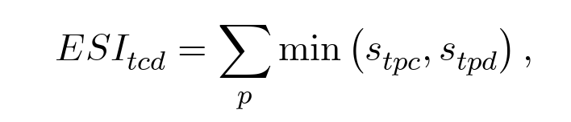
For instance, if “Wheat and products” constitutes a 0.01 share of total consumption in Spain and 0.02 share in France, the overlapping share is 0.01. Shares of consumption are calculated based on energy / kcal / day, which the UN FAO also frequently employs.

The similarity score is then calculated as a weighted sum of the overlapping shares by country pair. Following the methodology of the Country Food Similarity Index, we assign a 30%, 30% and 40% weighting respectively to meat and dairy, starch, and fruit and vegetables, which delivers the most realistic similarity score between countries.

As the Country Food Similarity Index also highlights, we note a few limitations in our calculation of similarity: while our study generalizes food consumption on a national level, we acknowledge that within a country there can be large disparities in cuisine. Since the UN FAO data only exi sts by country, however, we are unable to capture these nuances. Furthermore, we are only able to determine food similarity based on consumption of raw ingredients: we acknowledge that other factors like recipes and preparation methods are not reflected in our study.

Based on a visual inspection, this methodology generally yields sensible results. As expected, for instance, countries in the Mediterranean region have very high similarity scores, as do countries in geographical regions like Southeast Asia.
In detail:
Shared statehood:
- Claude says we can take the Correlates of War State System dataset, and identify historic unions since 1900 (so that it’s recent enough to be relevant for dietary similarity)
- Or with what megan sent: https://www.arcgis.com/home/item.html?id=6b836b2859194fdfa156458f2d2842e9
- However Claude also says that it might take a bit more effort and data-wrangling
- We could consider interacting with time since dissolution of union/length of union
- Alternatively, we could only look at the similarity of certain historical unions, such as Soviet-Union or Yugoslavia as a case study after our main regression.
  - To not go over-board, we could just visualize it. We could do average similarity of the entire ex-union, or similarity to a certain country (eg, Russia for soviet union)
  - What would be so cool, is if we could do an interactive map that shows the food similarity since the dissolution of these unions.
Trade:
- Likely endogenous! We could still add it but discuss.
Regression Method: Gravity Model (estimate Pooled OLS with Dyadic-Robust Standard Errors)
$Similarityij​=β0​+β1​ln(dij​)+β2​∣GDPi​−GDPj​∣+β3​SharedLangij​+β4​SharedRegionij​+εij​$

Description of regression strategy:
We estimate cross-sectional gravity-type regressions to examine the determinants of bilateral food similarity across countries. The unit of observation is a country pair. All models are estimated separately for 2010 and 2023.
The dependent variable is a continuous index of food similarity between two countries. The main explanatory variables include bilateral trade intensity, geographic distance, and standard gravity controls capturing cultural and historical proximity, such as common language, common religion, colonial ties, and trade agreements.
To account for unobserved country-specific heterogeneity, we include country fixed effects for both members of each pair. Standard errors are clustered at the country level in both dimensions (i.e., by each country in the dyad), allowing for arbitrary correlation of errors across dyads sharing a common country.

First Results:
- With country-fixed effects, we find that all geographical factors (distance of population weighted centroids, difference in distance to coast, shared border) are strongly correlated with food similarity.
- Trade and cultural factors might also play a role: common colonizer and trade agreements are significant
- All signs are as expected.
- Including gdp differences doesn’t change the results much. Gdp difference itself seems to be a relevant determinant.

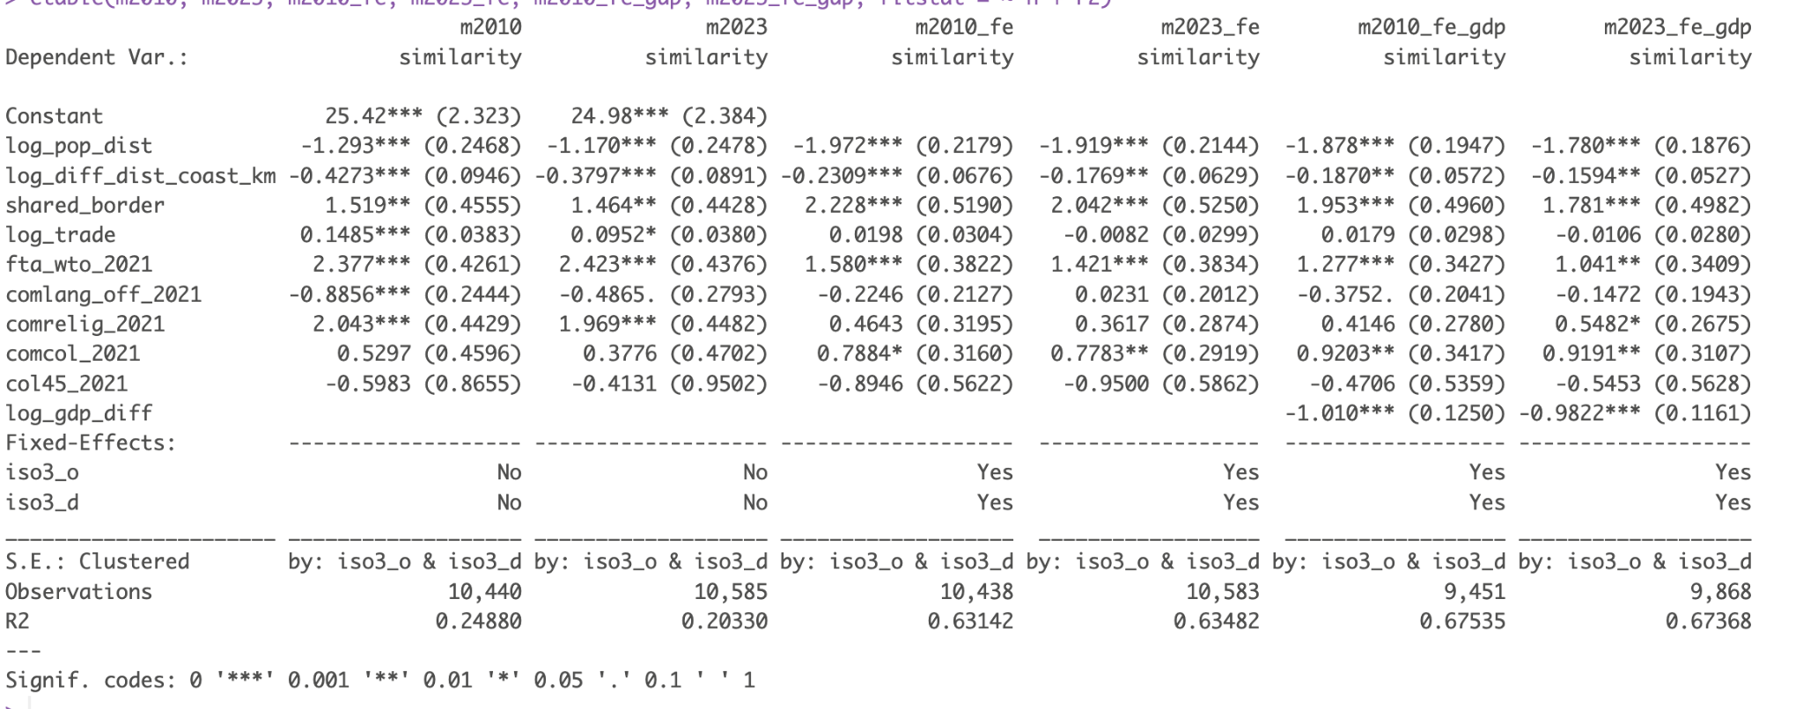

Megan’s message:
Potential research question: How geography shapes food similarity / differences across countries

Literature:
- https://pmc.ncbi.nlm.nih.gov/articles/PMC3832477/
- https://agricecon.agriculturejournals.cz/pdfs/age/2021/08/02.pdf: calculates food similarity between EU countries using the FAO data, could be a useful reference

DATA: UN FAO

Methodology:
- Calculate some sort of similarity score for each country pairing and run a regression with it

Potential avenues to explore:
- Distance from each other
- Similar max elevation / average elevation
- Similar climate zones
- Similar distance from the ocean, water bodies etc.
- Maybe impact of colonialism?
- Shared borders

E.g. I imagine regressing the similarity score on an indicator for past shared national boundaries (maybe interacted with how long ago it was), indicator for shared borders, distance from each other, some sort of ratio between their elevations/ differences between the elevation, an indicator for the same climate zones, etc.

oh and these are spatial operations we could do with this: - Constructing shared borders indicator (this probably exists already somewhere though if we need to save on work) / historical national boundaries indicator
- Calculating distance from each other
- Calculating distance from the ocean
- Rasters for: elevation, climate zones (https://koppen.earth/), water bodies https://land.copernicus.eu/en/products/water-bodies/water-bodies-global-v2-0-300m

ideas
Geospatial project ideas:

- Airbnb data: https://insideairbnb.com/get-the-data/
  - Determinants of airbnb prices
    - Distance from public transportation
    - Distance from major attractions
- Determinants of food similarity
  - FAOSTAT - database of food consumption by country
  - Inspired by: https://objectivelists.com/country-food-similarity-index/
- Flood risk as possible determinant of property prices (Airbnb or property transaction prices: UK Land Registry Price Paid Data / German Gutachterausschuss datasets (city-specific)
  - Official flood hazard maps (Copernicus / national agencies)
  - Location inside flood-risk zones / distance to rivers / coastline
- Dataset & geospatial tools to use

Decide by this weekend

https://journals.sagepub.com/doi/abs/10.1177/096977640200900304

tina notes
CEPII Gravity dataset relevant variables:

- country_id: Gravity country ID
- iso3: ISO3 alphabetic code
- iso3num: ISO3 numeric code
- country: Country name
- countrylong: Offcial country name

- comlang_off: 1 if countries share common official or primary language
- comrelig: Religious proximity index
- col45: 1 if countries are or were in colonial relationship post 1945
- comcol: 1 if countries share a common colonizer post 1945
- fta_wto: 1 if pair currently engaged in a regional trade agreement (source: WTO supplemented by Thierry Mayer)
- tradeflow_baci: Trade flow (in thousands current US$) (source: BACI)
- scaled_sci_2021: Social connectedness index in 2021

- dist: Geodesic distance between most populated cities (km)
- distcap: Geodesic distance between capital cities (km)

CAPII BACI dataset:
- v: value of trade flow (in thousands current US$)

https://oceans-and-fisheries.ec.europa.eu/news/eurobarometer-survey-shows-new-trends-fishery-and-aquaculture-products-consumption-2025-02-20_en#:~:text=Proximity%20to%20the%20sea%20strongly,200%20kilometres%20away%20(49%25).
https://pmc.ncbi.nlm.nih.gov/articles/PMC6561990/#Sec11
https://pmc.ncbi.nlm.nih.gov/articles/PMC3832477/
https://pmc.ncbi.nlm.nih.gov/articles/PMC6561990/#Sec11
https://www.jstor.org/stable/2231506
https://www.fao.org/statistics/highlights-archive/highlights-detail/food-balance-sheets-2010-2022-global-regional-and-country-trends/en

